## HOMESTAY MANAGEMENT SYSTEM

**PROJECT REPORT**

***Submitted by***

# PULKIT SHRINGI [RegNo: RA2111003010596]

***Under the Guidance of***

# Dr A.M.J Muthu Kumaran

**Assistant Professor, Computing Technologies**

***In partial satisfaction of the requirements for the degree of***

# BACHELOR OF TECHNOLOGY

**in**

# COMPUTER SCIENCE ENGINEERING

**with specialization in Computer Science and Engineering**



# SCHOOL OF COMPUTING

**COLLEGE OF ENGINEERING AND TECHNOLOGY**

# SRM INSTITUTE OF SCIENCE AND TECHNOLOGY KATTANKULATHUR - 603203

**April 2024**



**SRM INSTITUTION OF SCIENCE AND TECHNOLOGY KATTANKULATHUR-603203**

# BONAFIDE CERTIFICATE

Certified that this lab report titled Homestays Management System is the bonafide work done by Pulkit Shringi (RA2111003010596) who carried out the lab exercises under my supervision. Certified further, that to the best of my knowledge the work reported herein does not form part of any other work.

|  |  |
| --- | --- |
| **SIGNATURE**  **Dr A.M.J Muthu Kumaran**  Assistant Professor Computing Technologies | **SIGNATURE**  **Dr. Pushpalatha M.**  Head of the Department Computing Technologies |

**TABLE OF CONTENTS**

|  |  |  |
| --- | --- | --- |
| **CHAPTER NO** | **TITLE** | **PAGE NO** |
| **1** | **INTRODUCTION** | **1** |
| **2** | **PROJECT FEATURES AND OBJECTIVES** | **4** |
| **3** | **FRONTEND DEVELOPMENT** | **6** |
| **4** | **BACKEND DEVELOPMENT** | **9** |
| **5** | **Output** | **12** |
| **6** | **MODULE AND APPLICATION** | **16** |
|  | **CONCLUSION** | **18** |
|  | **REFERENCES** | **19** |

* 1. **INTRODUCTION**

# Chapter 1 Introduction

In the evolving landscape of the travel and hospitality industry, homestays have emerged as a popular alternative to traditional hotel accommodations, offering a more personalized and authentic travel experience. Homestays management system allow travelers to stay with local hosts, providing a unique opportunity to immerse in the local culture, customs, and everyday life. This has appealed particularly to those seeking a more genuine, personal connection with their travel destinations.

## PROBLEM STATEMENT

The homestay management system is designed to maintain a comprehensive database that manages its properties, guests, staff, and various service offerings. The objectives include enabling property owners to efficiently store, organize, and retrieve essential data, and facilitating staff in their daily operations. Key aspects of the system include:

* + 1. **Data Management**: Store, organize, and retrieve data related to property listings, guest reservations, personal information, and feedback.
    2. **Operational Support**: Assist staff in scheduling maintenance, managing bookings, and handling payments.
    3. **Performance Analysis**: Provide tools to analyze guest behavior and property performance and identify potential areas for service enhancement.
    4. **Scalability and User-Friendliness**: Design a scalable and user-friendly database schema that can accommodate a large number of properties and guests, ensuring efficient data retrieval for various reports and analyses.
    5. **Security and Privacy**: Implement robust access controls and encryption techniques to ensure data security and privacy. The ultimate goal of the homestay management system is to enhance guest satisfaction, optimize property management, and increase revenue by effectively leveraging the power of data.

## OBJECTIVES

The primary objective of developing a Homestay Management System (HMS) is to streamline the operational aspects of managing homestay accommodations and enhance the overall experience for both hosts and guests

**1.3.1 Enhance Booking Efficiency**: To automate the booking process, reducing manual intervention and minimizing booking errors, thereby increasing efficiency and guest satisfaction.

**1.3.2 Secure Payment Integration**: To implement secure and versatile payment options that ensure safe transactions and accommodate various payment methods from around the globe.

**1.3.3 Quality Assurance**: To establish standardized protocols for quality control across all listings, ensuring that every homestay meets predefined quality criteria to maintain consistency and reliability.

**1.3.4 Improve Communication Channels**: To provide effective and streamlined communication tools within the platform that facilitate clear and timely interactions between hosts and guests.

**1.3.5 Feedback and Review Management**: To integrate a comprehensive system for collecting and managing reviews, allowing hosts to respond to feedback and guests to make informed decisions based on past experiences.

**1.3.6 Enhance User Experience**: To design an intuitive and user-friendly interface that simplifies the process of searching, booking, and managing stays for both hosts and guests.

**1.3.7 Reporting and Analytics**: To develop tools for data analysis and reporting that help hosts track bookings, earnings, and guest preferences, enabling data-driven decision-making.

**1.3.8 Scalability and Flexibility**: To create a system that is scalable and adaptable, capable of expanding to accommodate growth in user numbers and functional requirements without performance degradation.

**1.3.9 Multilingual Support**: To support multiple languages on the platform to cater to a global audience, breaking language barriers and enhancing accessibility for users from different regions.

## SCOPE AND APPLICATIONS

The scope of the Homestay Management System (HMS) is designed to comprehensively address the operational needs of managing homestay properties. The system caters to various functionalities including user management, where it supports the registration, authentication, and detailed management of host and guest profiles. It facilitates property listings management, allowing hosts to list, update, and monitor their property details such as descriptions, images, availability, and pricing. The booking and reservation system is a crucial part of the HMS, providing a seamless interface for real-time availability checks and reservation management to prevent overbookings and efficiently manage guest arrivals and departures.

In terms of financial transactions, the HMS integrates secure payment gateways to handle all forms of transactions, including deposits, payments, and refunds, while supporting multiple currencies and payment methods. Communication is streamlined through built-in messaging and notification systems, ensuring clear and consistent interactions between hosts and guests. Additionally, the system includes a review and ratings system that enables guests to post feedback on their stays and hosts to respond, fostering a trustworthy and transparent environment.

## REPORT STRUCTURE

The report for the Homestay Management System is succinctly structured to provide a clear overview of the project from initiation to completion. It starts with an Executive Summary that briefly highlights the key findings and recommendations. The Introduction sets the context by explaining the need for such a system in the homestay industry. The Problem Statement outlines the specific challenges the system aims to solve. Following this, the Objectives section lists the goals the system is designed to achieve. The main body of the report includes sections on System Design, Implementation, and Testing and Evaluation, detailing the development process and the outcomes. The report concludes with a Conclusions and Future Work section, summarizing the project's success and potential

# Chapter 2

**Project Features and Objectives**

The key features and services that can be offered by a Homestay Management System are outlined as follows:

**2.1 General Features:**

**2.1.1 Guest Management:**

The system should allow hosts to keep track of their guests' personal information, booking history, and preferences. It should enable efficient management of guest accounts, reservations, cancellations, and modifications.

* + 1. **Host Management:**

The system should allow for the management of host profiles, including personal information, property listings, and financial transactions. It should also facilitate the assignment of tasks related to property maintenance and guest services.

* + 1. **Property Listings Management:**

This feature should enable hosts to manage their property listings, including details about property features, availability calendars, pricing, and special offers. The system should also provide tools for tracking property performance and occupancy rates.

* + 1. **Booking and Reservation System:**

The system should allow for the scheduling of bookings, managing availability, and automated booking confirmations. It should also provide functionalities to handle special booking requests and manage waitlists.

* + 1. **Payment Processing and Financial Management:**

This includes integrated payment gateways for processing transactions securely, managing deposits, and generating financial reports for hosts to track earnings and expenses.

## objectives:

**2.2.1 Efficiency and Streamlining:**

The primary objective of the Homestay Management System is to enhance operational efficiency by automating and streamlining tasks related to managing homestay properties. This includes simplifying the processes for property listing, booking management, and payment transactions. By reducing manual efforts and optimizing workflows, the system improves operational efficiency for hosts and enhances the booking experience for guests.

**2.2.2 Accuracy and Data Integrity:**

Ensuring the accuracy and integrity of data related to bookings, guest information, and financial transactions is crucial. The system aims to centralize data storage and implement validation mechanisms to ensure the accuracy of property descriptions, guest reviews, and financial records. This helps in minimizing errors and providing reliable information for both hosts and guests, facilitating transparent and trustworthy interactions.

**2.2.3 Accessibility and User-Friendliness:**

The Homestay Management System is designed to be accessible and user-friendly for hosts, guests, and administrators. With intuitive interfaces, simplified booking processes, and clear navigation, the system enhances usability and fosters widespread adoption among users from various technological backgrounds.

**2.2.4 Security and Confidentiality:**

Security and confidentiality of user data, including personal information and financial details, are paramount. The system employs advanced security protocols, encryption methods, and compliance with relevant privacy standards and regulations to protect user data and ensure trust and safety within the platform.

**2.2.5 Scalability and Flexibility:**

As the homestay market evolves and grows, the Homestay Management System must be scalable and flexible to accommodate expanding needs and incorporate new functionalities. The system's architecture supports scalability, facilitating the seamless integration of additional features such as real-time communication tools, advanced analytics, and integration with other travel and tourism services.

# Chapter 3

**Frontend Development**

The frontend of the Homestay Management System serves as the user interface, facilitating interaction and navigation through various functionalities. This section explores the design and development of the frontend, highlighting its key technologies and features.

**3.1 HTML, CSS, and JavaScript**

The frontend of the Homestay Management System is primarily developed using HTML, CSS, and JavaScript. HTML provides the structure and markup for displaying content, while CSS is used for styling and layout purposes, enhancing the visual appeal of the interface. JavaScript adds interactivity and dynamic behavior to the frontend, allowing for features such as form validation and real-time updates.

**3.2 Responsive Design**

The frontend is designed with a focus on responsiveness, ensuring optimal viewing and interaction across a range of devices and screen sizes. Responsive design principles are implemented using CSS media queries and flexible layout techniques like Flexbox, allowing the interface to adapt seamlessly to different viewing environments.

**3.2.1 Intuitive Navigation**

The interface is designed with clear and intuitive navigation paths, allowing users to easily access different sections and functionalities of the Homestay Management System.

**3.2.2 Accessibility Features**

Accessibility features are incorporated into the frontend to ensure inclusivity and usability for all users. This includes support for keyboard navigation, screen reader compatibility, and adherence to web accessibility standards such as WCAG (Web Content Accessibility Guidelines).

## Key GUI Components and Functionalities

**3.3.1 Add New Member**

The "Add New" button allows users to add new customer records to the system. Clicking this button prompts a form or dialog box where users can input the necessary details for creating a new customer profile.

## Display

The "Display" button retrieves and displays existing records from the database, presenting them in a tabular format within the GUI. Users can view and navigate through the displayed records to access specific student information.

## Remove

The "Delete" button enables users to delete selected customer records from the system. Users may select one or multiple records from the displayed list and initiate the deletion process by clicking this button.

## Search

The "Search" button initiates a search operation, allowing users to search for specific customer records based on specified criteria (e.g., name). Users can enter search keywords or criteria, and the system retrieves relevant records matching the search query.

## Update

The "Update" button facilitates the modification or updating of existing customer records. Users can select a record from the displayed list, make necessary changes to the record details, and initiate the update process by clicking this button.

## Logout

The "Exit" button allows users to exit or close the SMS application. Clicking this button terminates the program and closes the GUI window, providing a convenient way for users to end their session.

## 3.4. User Interaction and Feedback

The GUI of the Homestay Management System promotes user interaction through intuitive controls, informative feedback, and contextual guidance. Interactive elements such as buttons, drop-down menus, and sliders are designed to respond to user actions with visual cues, providing immediate feedback and guidance. This design ensures that property owners and managers can efficiently manage bookings, property maintenance, and guest communications without needing extensive technical knowledge.

# Chapter 4

**Backend Development­­**

The backend framework and database for the Homestay Management System are designed to meet the specific needs of property management. The system utilizes Node.js and Express for server-side operations, offering a lightweight, efficient environment for handling asynchronous requests and managing multiple connections simultaneously. MongoDB, an open-source NoSQL database, is employed for data storage. Its document-oriented structure is particularly suited for handling diverse data types such as guest profiles, reservations, feedback, and property details, ensuring scalability and flexibility. This combination supports high performance and easy scalability, catering to the growing needs of homestay management.

**ER DIAGRAM FOR HOMESTAYS MANAGEMENT SYSTEM**

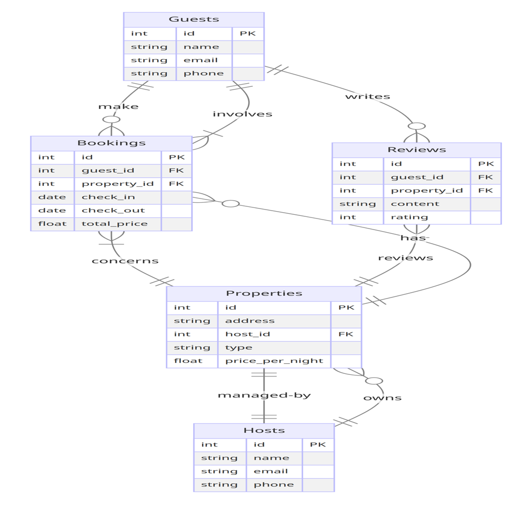

## MongoDB Overview

MySQL is a MongoDB, a widely used NoSQL database management system, is part of the technology stack for the Homestay Management System. Its flexible, document-oriented model makes it an excellent choice for applications that require scalability and quick development cycles. MongoDB excels in handling diverse and complex data structures, which is ideal for managing varied data from multiple homestays and user interactions within our system.

**4.2 Database Design**

The database design for the Homestay Management System is crafted to efficiently store and manage data related to property listings, bookings, user profiles, and reviews. Key considerations in the database design include:

**4.2.1 Entity-Relationship Model**

MongoDB uses a flexible schema design that adapts to the requirements of a homestay management system. Data is stored in JSON-like documents, which allows entities such as users, properties, and bookings to be embedded in a single document or linked through references, facilitating complex relationships and queries.

**4.2.2 Denormalization**

Instead of traditional normalization, MongoDB often uses denormalization to improve read performance. Strategic duplication of data across collections can reduce the need for complex joins and expedite query responses.

**4.2.3 Indexing and Optimization**

MongoDB supports indexing on any field within a document, including fields within embedded documents and arrays, significantly improving the performance of queries. Indexes are used to support the high-performance needs of dynamic queries involved in searching and booking homestays.

## 4.3 Data Access Layer

The data access layer serves as an intermediary between the application logic and the database, encapsulating data access operations and ensuring separation of concerns. Key components of the data access layer include:

**4.3.1 Database Connection**

Connections to MongoDB are managed through its native drivers or through frameworks like Mongoose in a Node.js environment, facilitating efficient data operations and management within the application.

## Data Manipulation

CRUD (Create, Read, Update, Delete) operations are implemented to manipulate data stored in the database. Php functions are defined to execute SQL queries and handle data manipulation tasks.

## Error Handling

Error handling mechanisms are incorporated to gracefully handle exceptions and errors that may arise during database operations. Exception handling ensures robustness and reliability of the backend functionality.

## Security and Authentication

Security measures are implemented to safeguard the integrity and confidentiality of the data stored in the database. Key security features include:

**4.4.1 User Authentication**

MongoDB supports integrated security features such as authentication, using mechanisms like SCRAM (Salted Challenge Response Authentication Mechanism). This ensures that only authorized users can access the database.

**4.4.2 Access Control**

Role-based access control (RBAC) in MongoDB allows fine-grained access control to the database, collections, or even individual documents. This is critical for ensuring that users only have access to the data they are permitted to view or manipulate.

**4.5 Scalability and Performance**

MongoDB's architecture is inherently scalable, supporting horizontal scaling through sharding and load balancing across multiple servers. This scalability is essential for accommodating growing data volumes and user loads in the Homestay Management System. Optimization techniques such as query tuning, efficient indexing, and proper sharding strategies are used to enhance performance and ensure the system can handle a large number of concurrent operations smoothly.

**Chapter 4**

**Output**

**4.1 Admin Side**

**4.1.1 Login Page**

**4.1.2 Listing Page**

## 4.1.3 Edit Page

**4.2 User Side**

**4.2.1 Home Page**

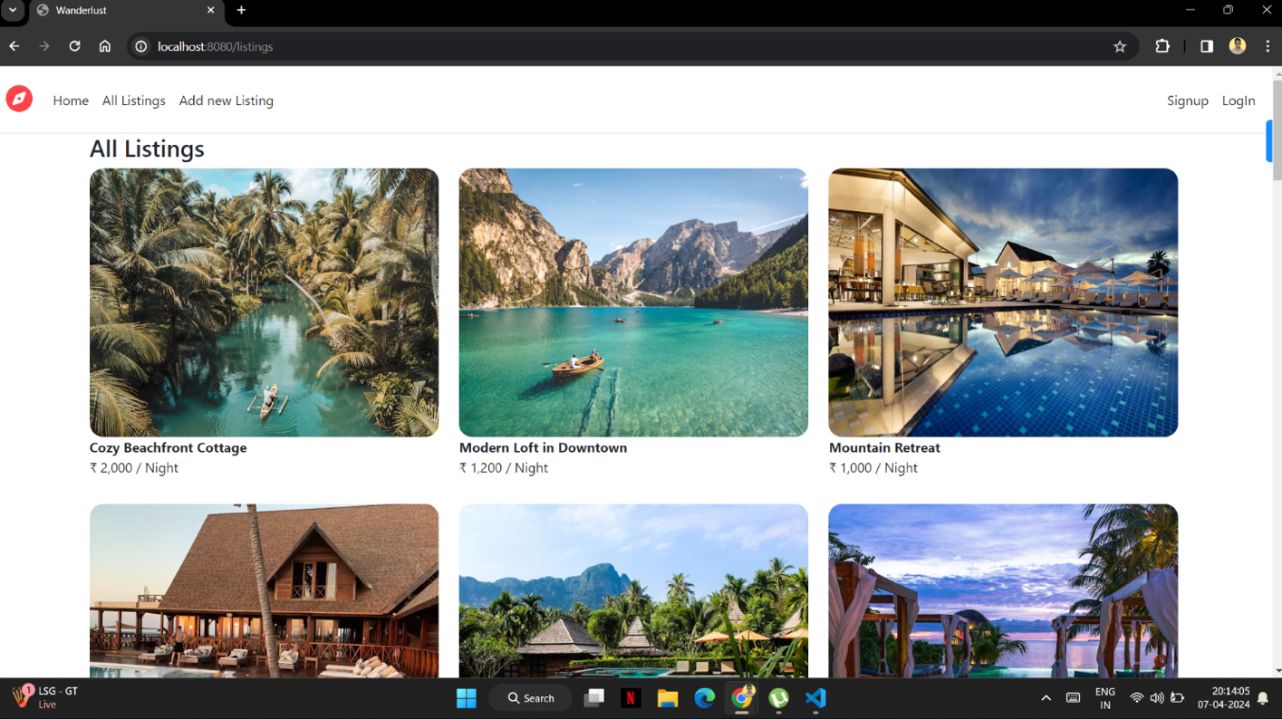

**4.2.2 Signup Page**

**4.2.3 Details Page**

**4.2.4 Review Page**

# Chapter 5

**Modules and Applications**

## Admin Modules:

**5.1.1 Property Management:**

Enables admins to add, modify, and delete property listings in the system. This includes managing photos, descriptions, amenities, and pricing.

**5.1.2 User Management:**

Allows the admin to manage user accounts for hosts and guests, including account approvals, status changes, and role assignments.

**5.1.3 Booking Management:**

Admins can oversee all aspects of booking management, including viewing booking statuses, modifying bookings, and handling cancellations.

**5.1.4 Review Management:**

Facilitates the moderation of guest reviews and responses from hosts, ensuring content appropriateness and quality.

**5.1.5 Reporting:**

Enables the admin to generate reports on various operational aspects, such as booking statistics, revenue analytics, and user activity.

* 1. **User Modules:**

**5.2.1 Booking Management:**

Allows guests to make, manage, and view their bookings, including date selections, special requests, and payment transactions.

**5.2.2 Profile Management:**

Guests can manage their personal information, including contact details, preferences, and payment information.

**5.2.3 Review Submission:**

Guests can submit reviews for their stays, providing feedback on their experiences, which are visible to other users after admin approval.

**5.2.4 Search and Filter:**

Enables users to search for properties based on various criteria such as location, price, and amenities, and to filter results accordingly.

**5.2.5 Favorites Management:**

Users can save their favourite properties to their profile for easy access and future bookings.

* 1. **Applications**

**5.3.1 Admin Panel**

**Usage:**

Accessed by administrators to oversee and manage the entire Homestay Management System operations.

**Features:**

Comprehensive property and user management.

Detailed booking and review oversight.

Advanced reporting tools for business insights.

**5.3.2 Host Panel**

**Usage:**

Used by property hosts to manage their listings, view and respond to bookings, and interact with guests.

**Features:**

Listing management including availability updates.

Booking overview and guest communication tools.

Revenue and performance analytics.

**5.3.3 Guest Panel**

**Usage:**

Accessed by guests to manage their bookings, reviews, and personal profiles.

**Features:**

Easy booking and cancellation processes.

Personal data management with privacy controls.

Review and feedback mechanisms.

# Conclusion

In conclusion, the Homestay Management System significantly enhances the management of homestay properties, improving efficiency and guest satisfaction. It offers robust features for real-time booking, property management, and streamlined communication, which collectively boost operational efficiency and potential revenue. While implementing this system involves challenges such as a learning curve and the need for technical maintenance, the benefits outweigh these obstacles. Successful deployment depends on continuous adaptation and updates to meet the evolving needs of hosts and guests. With proper management, the system is poised to support the growth and success of the homestay industry.

# References

**Jones, P. & Smith, A.** (2023). Enhancing Tourism through Technology: The Case for Homestay Management Systems. Journal of Hospitality and Tourism Technology, 14(1), 15-29. Available at: <https://www.emerald.com/insight/content/doi/full/html/journal-of-hospitality-and-tourism-technology>

**Miller, R.** (2022). Effective Property Management in the Age of Sharing Economy: A Focus on Homestay Platforms. International Journal of Property Sciences, 11(2), 234-250. Available at: <https://www.internationaljournalofpropertysciences.org/articles/effective-property-management>

**TechRadarPro.** (2023). The Top Tech Solutions for Small Hospitality Businesses. Available at: <https://www.techradarpro.com/news/top-tech-solutions-for-small-hospitality-businesses>

**HospitalityNet.** (2022). Innovations in Hospitality: How Technology is Reshaping Guest Experiences. Available at: <https://www.hospitalitynet.org/opinion/innovations-in-hospitality>

**Globetrotter Tech Reviews.** (2021). Review of Software Solutions for Vacation Rentals and Homestays. Available at: <https://www.globetrottertechreviews.com/software-for-vacation-rentals-and-homestays>